NAME____________________________LAB MEETING DAY/TIME______________

Lab 10: Cenozoic Earth - KEY

In this lab you will continue to examine geologic maps and explore the Cenozoic features of the western U.S., as well as evidence of glaciations of the Pleistocene. This lab is a take-home lab, meaning you will work on the lab on your own time. Please see the Lab 10 assignment in Brightspace for details on how to complete and submit this lab.

# **Exercise 19, Part A**

**Follow the procedure on page 287 of your lab book to complete the table below. Note that the first one was done for you in the overview video.**

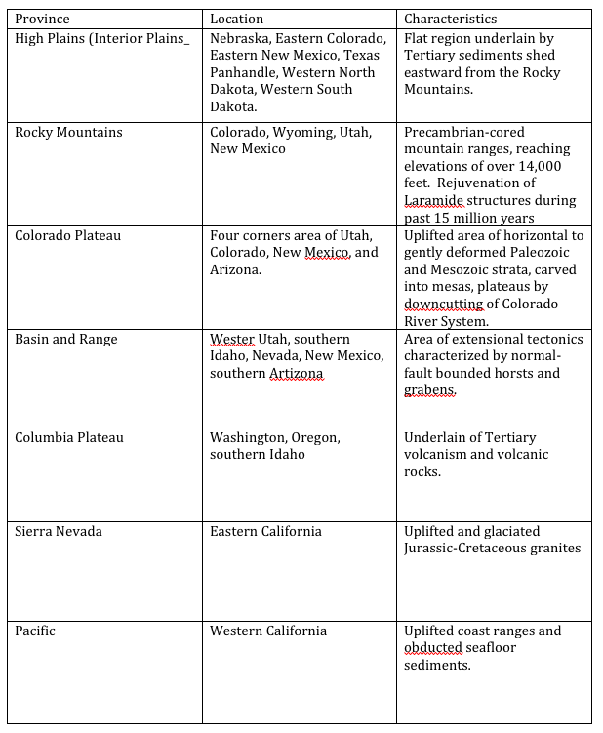

# **Exercise 19, PART B**

**Read the introduction to this activity. Be sure to watch the overview video for a discussion of the questions.**

**Question 1.**

***Flash floods during the spring when rain caused rapid melting of snow in the mountains on the east margin of the map area.***

***Any description of how alluvial fans form is fine here. Here is one from the Utah Geological Survey: ”*** ***Alluvial fans are created as flowing water interacts with mountains, hills, or steep canyon walls. Silt, sand, gravel, boulders, and woody debris can be deposited over time by powerful rivers or small creeks.”*** [***https://gis.utah.gov/data/geoscience/alluvial-fans/***](https://gis.utah.gov/data/geoscience/alluvial-fans/)

**Question 2.**

***Flooding, landslides, mass movements of sediment***

**Question 3.**

***Normal faults. Tensional stresses***

**Question 4.**

***Severe earthquakes, ground shaking, rock falls and landslides; all of which are typical of populated areas along steep mountain fronts and fault-prone areas.***

# **Exercise 20, PART A**

**Read the introduction to this activity. Be sure you’ve watched the overview video for a discussion of this exercise.**

**Question 1.**

***Oldest to youngest is Nebraskan, Kansan, Illinoian, and Wisconsin.***

**Question 2.**

***In Chicago, ice flowed north-northeast to south-southwest. In Ft. Wayne, ice flowed from northeast to southwest. In Mankato, ice flowed from north-northwest to south-southeast.***

**Question 3.**

***Both rivers flow along the front of the glacial deposits, initially flowing along the front of the Pleistocene ice sheets. Waters flowing toward the glacier were re-routed along the ice front.***

**Question 4.**

***This is known as the driftless area. Ice flowed around this area, probably due to the existence of an impediment that deflected ice to the west and to the east.***

**Question 5.**

***Continental glaciers disrupted the pre-Pleistocene drainage patterns. When the ice melted, meltwater flowed into local topographic lows to form temporary lakes.***

**Question 6.**

***Isostatic forces active since the melting of the mile-thick ice would result in uplift of the area.***

# **Exercise 20, PART B**

**Read the introduction to this activity. Be sure you’ve watched the overview video for a discussion of this exercise.**

**Question 1.**

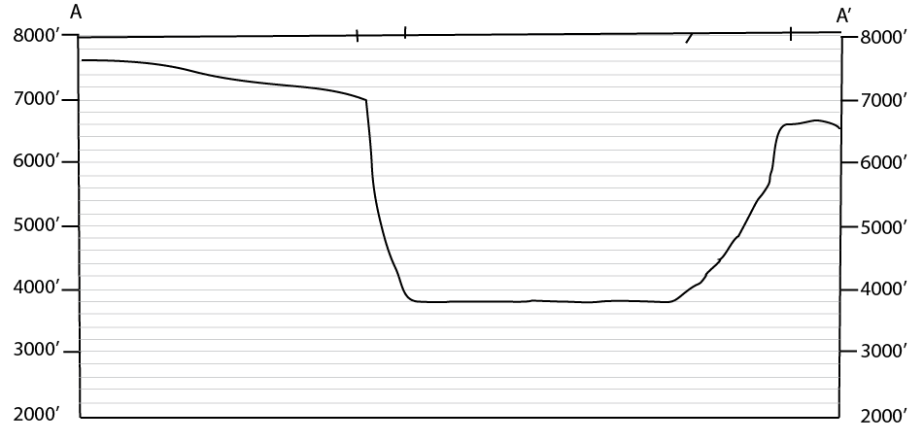

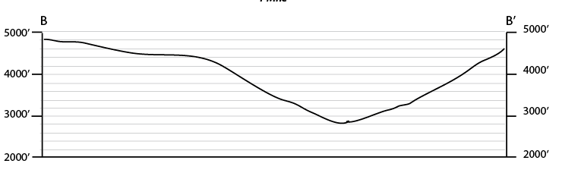

**Question 2.**

***The western Merced valley is V-shaped and only 1,400 ft deep. By contrast, Yosemite Valley is deeper (over 3,000 ft deep) with sub-vertical, vertical, and overhanging walls.***

**Question 3. SHOW YOUR WORK**

***The elevation of the Merced River just upstream from mile 124 is 3,920 ft. Approximately one mile farther upstream at El Cap Bridge, the Merced River is situated 3,950 ft above sea level. Hence the gradient is 30 ft per mile.***

**Question 4. SHOW YOUR WORK**

***The gradient is 400 ft per mile.***

**Question 5.**

***Bridal Veil Falls***

**Question 6.**

***Glaciers widen, deepen, and straighten the valleys through which they flow.***